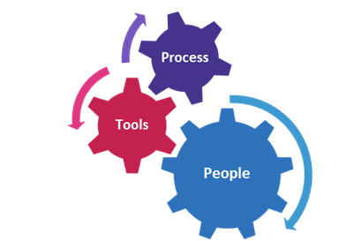
  - Getting professional about presentations now
    - Lighting, video, sound, interactivity planning
    - Attire
    - Scripting and timing
  - Determining how presentations can be a “new normal” tool for on-going business operations and business objectives
    - Replaces in-person presentations including market visits for BTB and to BTC activities
    - Evergreen content options
  - Developing a content strategy
    - Content beyond “chatting”
    - What is the value proposition for the potential viewer?
    - How do virtual presentations match and expand existing content strategies?
    - Are live attendees or evergreen value prioritized? (If its value is a live event only, treat it as such which requires more time in advance for proper marketing.)
  - Developing a marketing plan
    - “Build it and they will come” only works in the movies
    - There’s an overwhelm of virtual content right now; who are you trying to reach and how can you stand out?
    - Minimize friction to attendees
  - Getting started and get clarity as you go (but start with at least one clear goal.)

